**SQL: select** * **from** dataset_1;

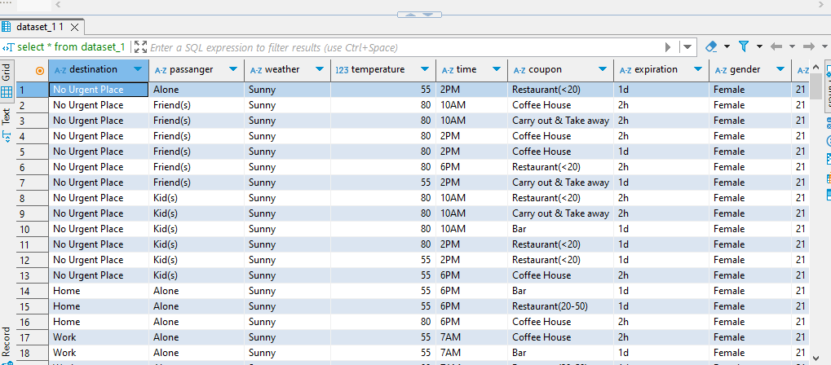

Python: df name is vehicle

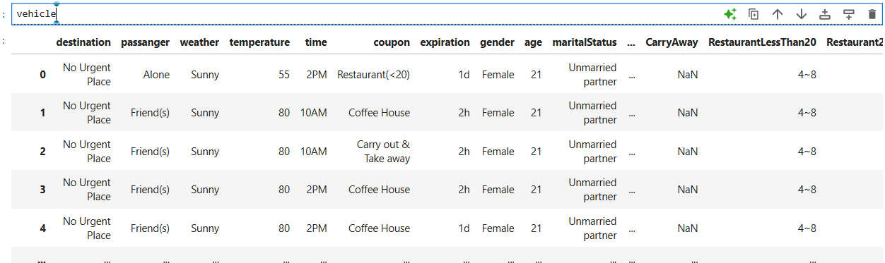

SQL: **select** weather,temperature **from** dataset_1;

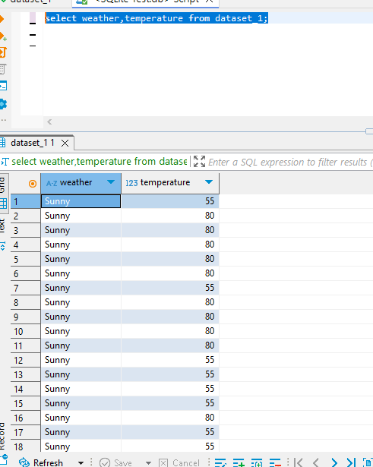

Python: vehicle[['weather','temperature']]

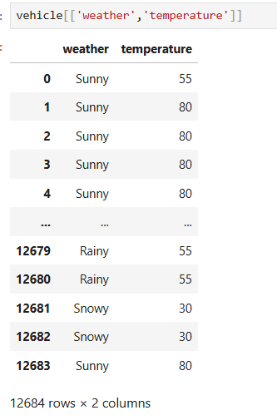

SQL: **select** * **from** dataset_1 **LIMIT** 10;

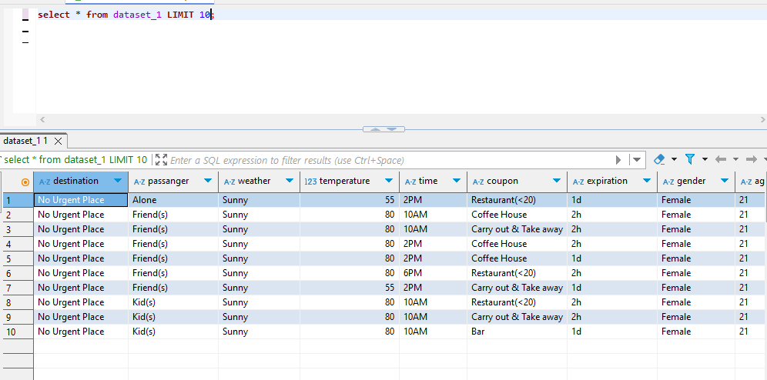

Python: vehicle.head(10)

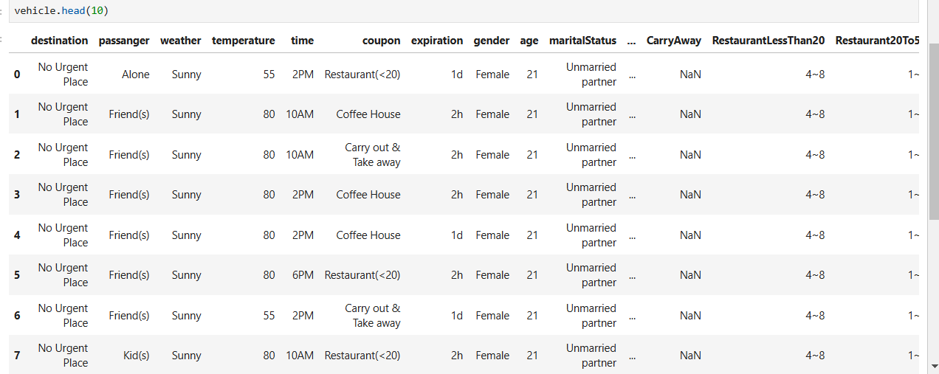

SQL: **select** **DISTINCT** passanger **from** dataset_1;

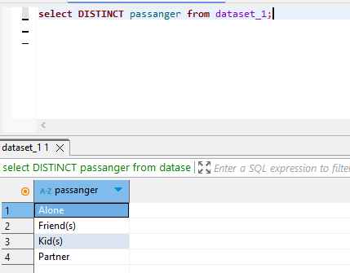

Python: vehicle.paasanger.unique() or vehicle[‘passanger’].unique()

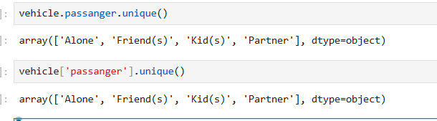

SQL: **select** * **from** dataset_1 **WHERE** destination = 'Home';

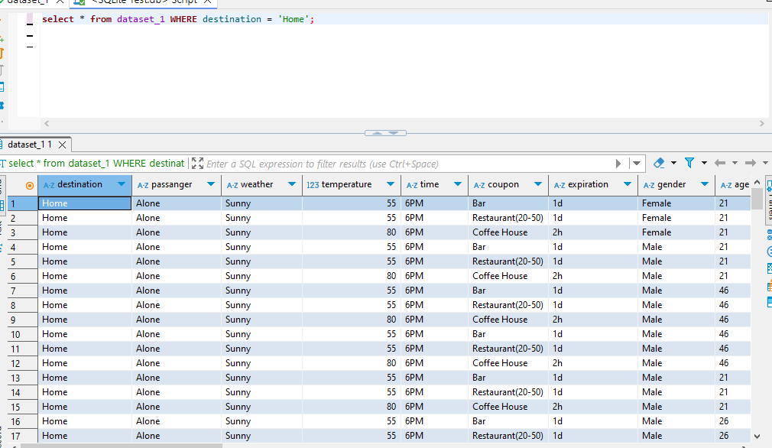

Pythin:vehicle[vehicle[‘destination’]==’Home’] or vehicle[vehicle.destination ==’Home’]

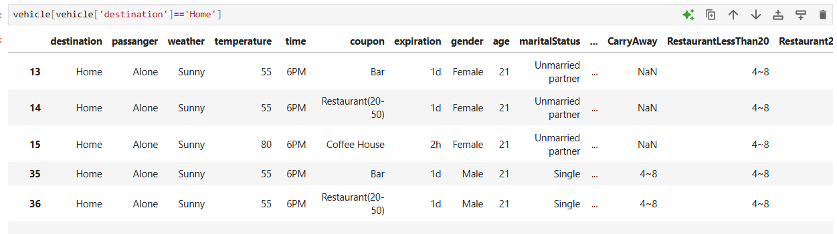

SQL: **select** * **from** dataset_1 **order** **BY** coupon ;

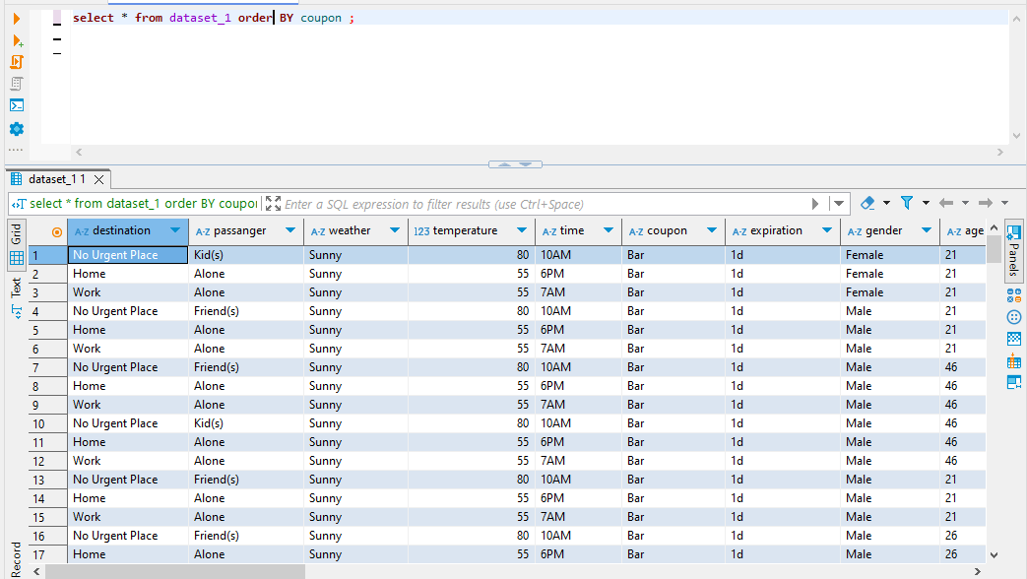

Python: vehicle.sort_values(by=’coupon’)

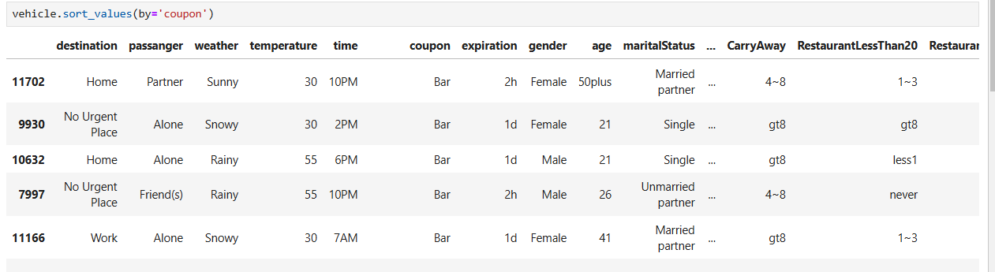

SQL: **select** destination **AS** *'Destination'* **from** dataset_1 ;

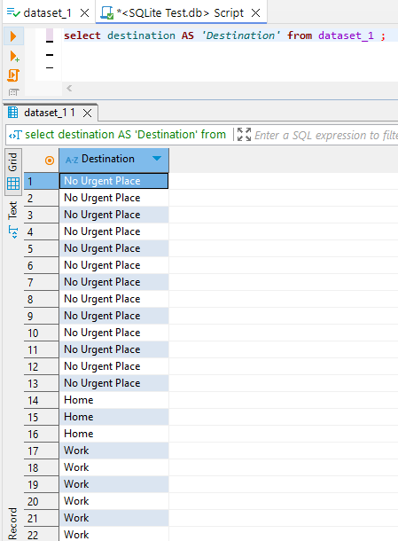

Python: dest1=pd.DataFrame()

Dest1=vehicle[‘destination’]

Dest1

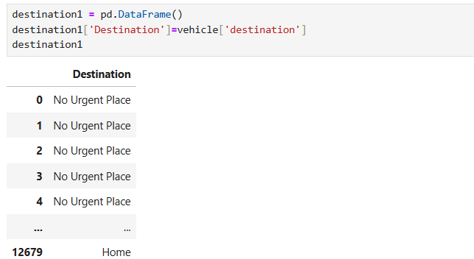

SQL: **select** occupation **from** dataset_1 **GROUP** **BY** occupation ;



Python: vehicle.groupby(‘occupation’).size().reset_index(name=’count’)

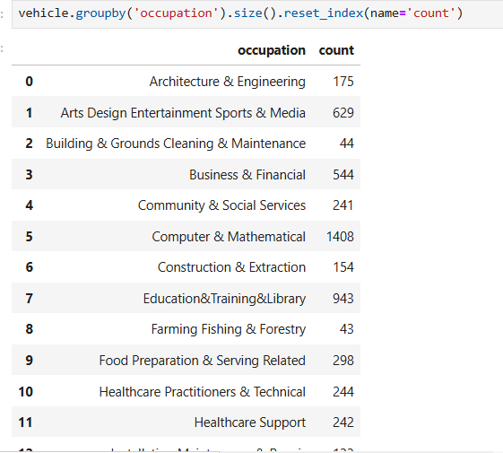

SQL: **select** weather,**avg**(temperature) **from** dataset_1 **GROUP** **BY** weather ;

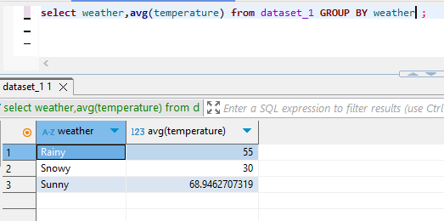

Python: vehicle.groupby(‘weather’)[‘temperature’].mean().reset_index(name=’avg(temperature’))

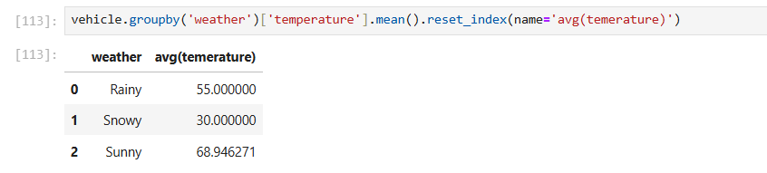

SQL: **select** weather,**count**(temperature) **AS** *count_temp* **from** dataset_1 **GROUP** **BY** weather ;

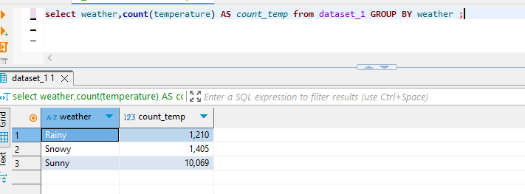

Python: vehicle.groupby(‘weather’)[‘temperature’].count().reset_index(name=’count_temp’)

Vehicle.groupby(‘weather’)[‘temperature’].size().reset_index(name=’count_temp’)

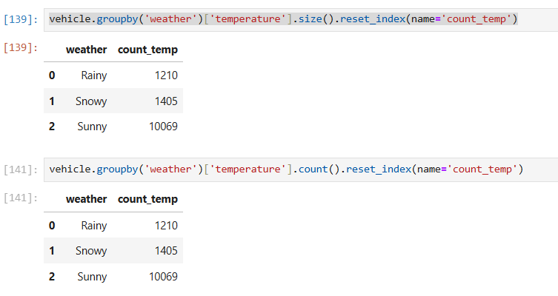

SQL: **select** weather,**count**(**DISTINCT** temperature) **AS** *count_dist_temp* **from** dataset_1 **GROUP** **BY** weather ;

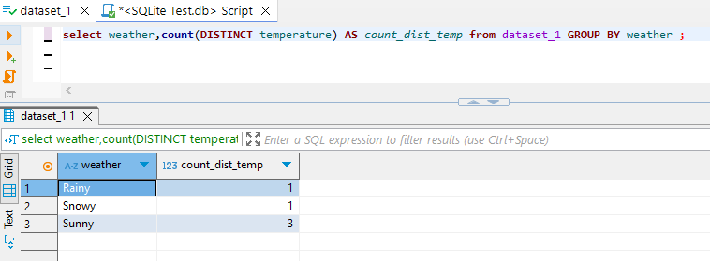

Python: vehicle.groupby(‘weather’)[‘temperature’].nunique().reset_index(name=’count_dist_temp’)

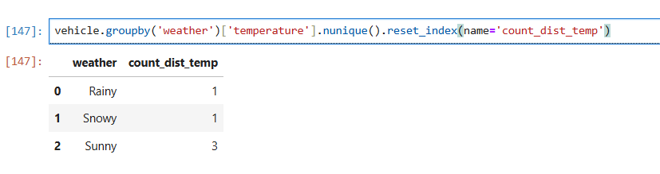

SQL: **select** weather,**sum**(temperature) **AS** *sum_temp* **from** dataset_1 **GROUP** **BY** weather ;

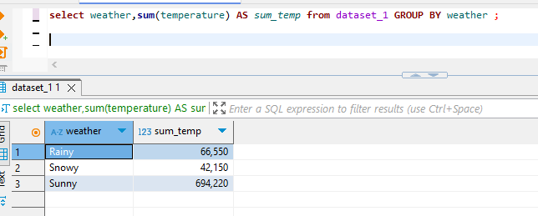

Python: vehicle.groupby(‘weather’)[‘temperature’].sum().reset_index(name=’sum_temp’)

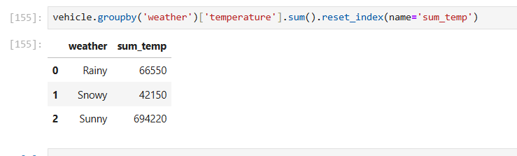

SQL: **select** weather,**min**(temperature) **AS** *min_temp* **from** dataset_1 **GROUP** **BY** weather ;

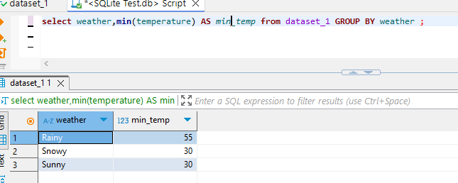

Python: vehicle.groupby(‘weather’)[‘temperature’].min().reset_index(name=’min_temp’)

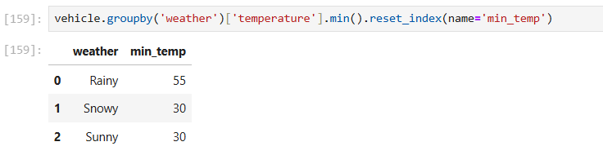

SQL: **select** weather,**max**(temperature) **AS** *max_temp* **from** dataset_1 **GROUP** **BY** weather ;

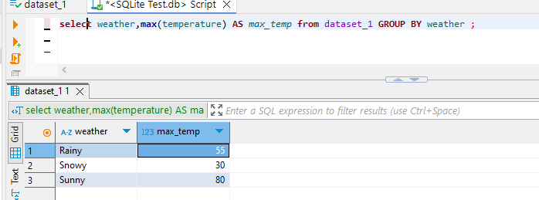

Python: vehicle.groupby(‘weather’)[‘temperature’].max().reset_index(name=’max_temp’)

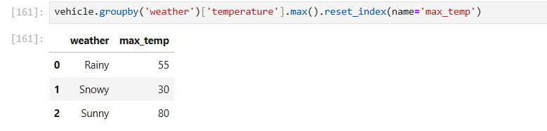

SQL: **SELECT** **DISTINCT** destination **FROM** (**SELECT** * **FROM** dataset_1 *d* **UNION** **SELECT** * **FROM** table_to_union *ttu*) ;

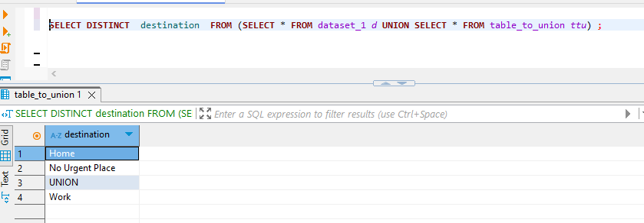

Python:veh1=pd.DataFrame(columns=vehicle.columns)

Veh1=’Union’

Pd.concat([vehicle,veh1])[‘destination’].drop_duplicates()

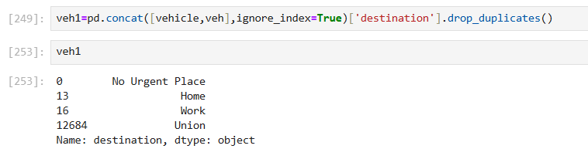

SQL: **SELECT** *d*.destination,*d*.time,*ttj*.part_of_day **FROM** dataset_1 *d* **INNER** **JOIN** table_to_join *ttj* **WHERE** *d*.time =*ttj*.time ;

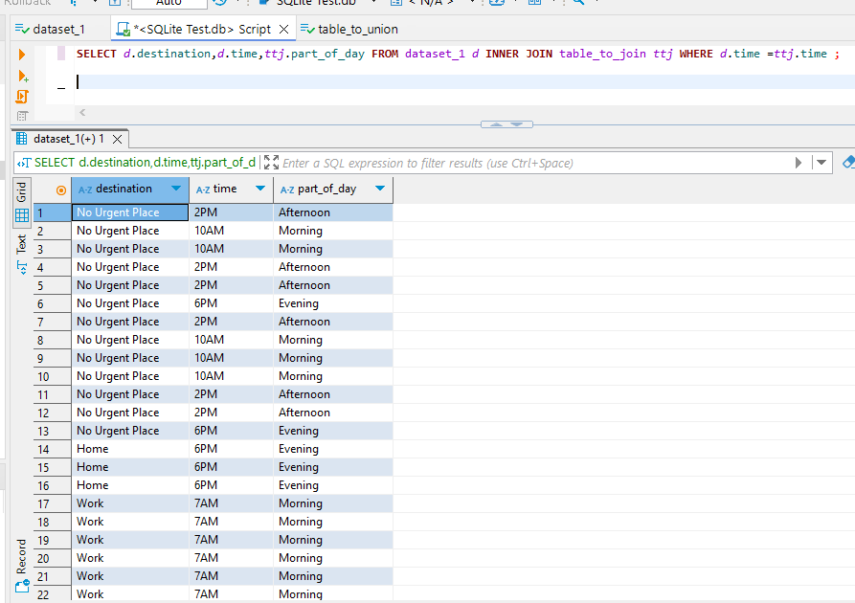

Python:pd.merge(vehicle,unionData,how=’inner’,on=’time’)[[‘destination’,’time’,’part_of_day’]]

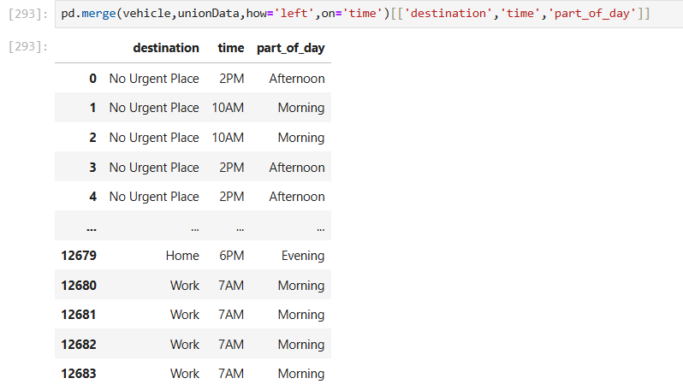

SQL: **SELECT** destination,passanger **FROM** (**SELECT** * **FROM** dataset_1 *d* **WHERE** passanger='Alone') ;

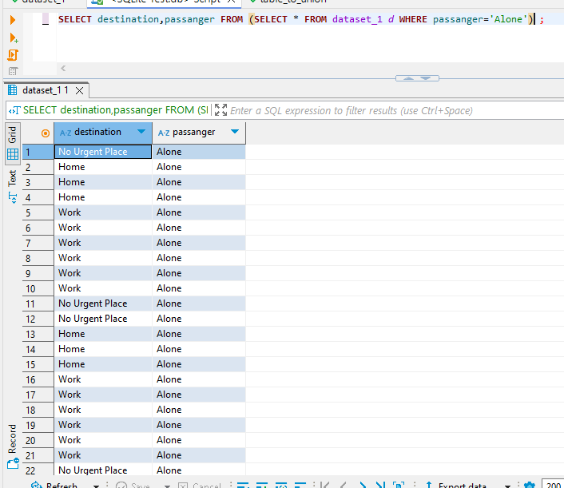

Python: vehicle[vehicle[‘passanger’]==’Alone’][[‘destination’,’passanger’]]

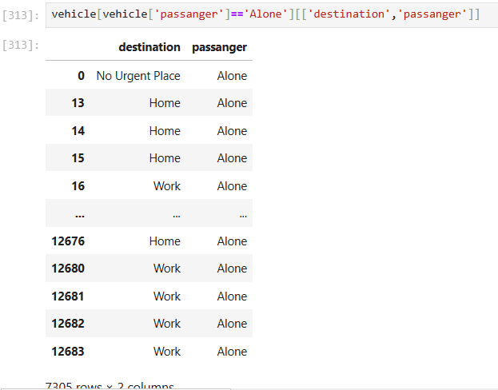

SQL: **SELECT** * **FROM** dataset_1 *d* **WHERE** weather **LIKE** 'Sun%'

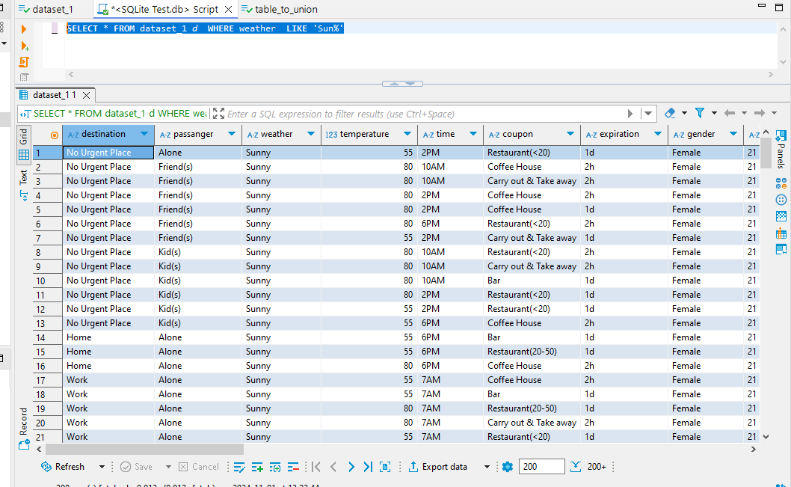

Python: vehicle[vehicle[‘weather’].str.startswith(‘Sun’)]

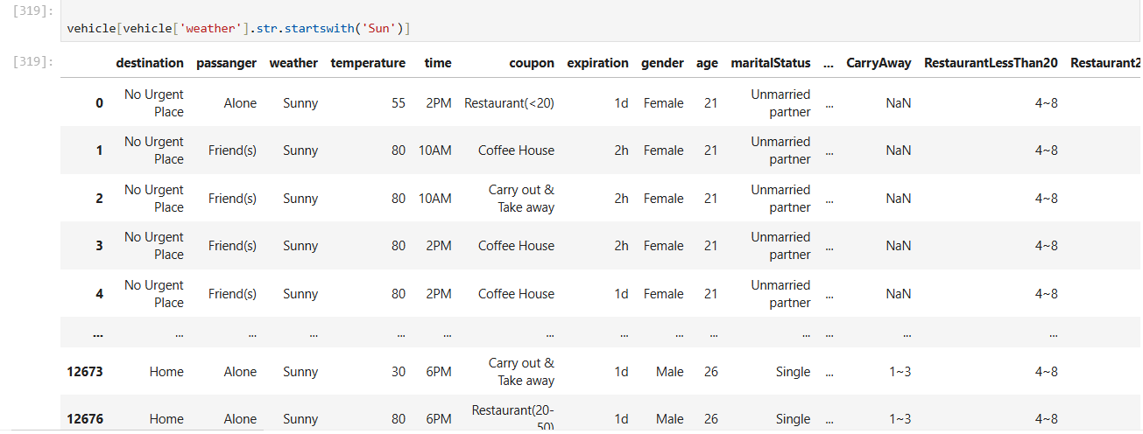

SQL: **SELECT** **DISTINCT** temperature **FROM** dataset_1 *d*

**WHERE** temperature **BETWEEN** 29 **AND** 75;

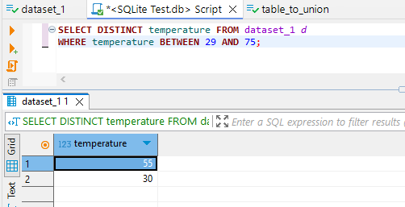

Python: vehicle[(vehicle[‘temperature’]>=29) & (vehicle[‘temperature’]<=75)][‘temperature’].unique()

Vehicle.query(‘temperature >=29 & temperature <=75’)[‘temperature’].unique()

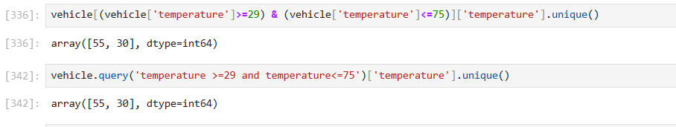

SQL: **SELECT** occupation **FROM** dataset_1 *d*

**WHERE** occupation **IN** ('Sales & Related','Management');

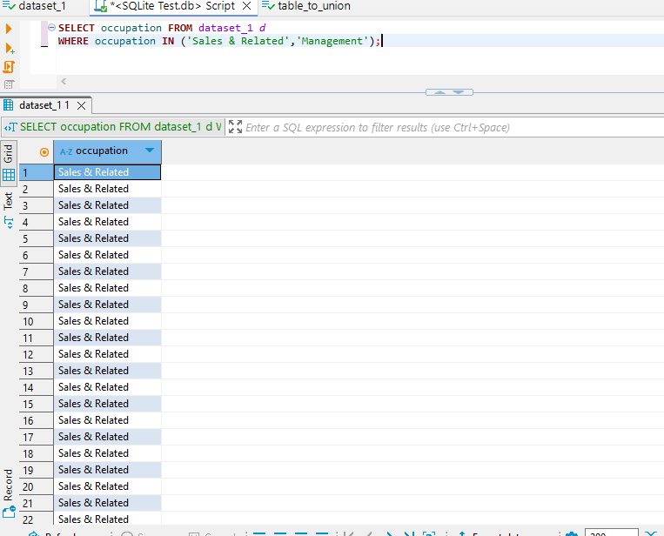

Python: vehicle.query(‘occupation==\’Sales & Related\’ | occupation==\’Management\’’)

Or

Vehicle[Vehicle[‘occupation’].isin(‘Sales & Related’,’Management’)][‘occupation’]

